Meeting Agenda: Synthetic Data & Model Scope Definition
Project: Synthetic Fraud Pattern Modelling (ORIGIN) Student: Tonmoy Saha Choyon Date: 30th January 2026

Part 1: Defining the Data Structure (The "Input")
Goal: To ensure the synthetic data we build matches the actual system architecture.
Question 1: The Schema Template
"We have the Feature List from the Excel file, but do you have a 'Golden Template' or JSON Schema for a single upload event that you can share with us?"
- Why I am asking (Internal Note): I cannot generate data if I don't know the structure. Is it a flat CSV row? Is it a nested JSON object where one "Upload" contains 10 "Songs"?
- Elaboration Script (If they ask, "Why do you need this?"): "The Excel file lists the features, but not the hierarchy. For example, does the id_device_fingerprint sit at the 'Account Level' or the 'Upload Level'? Knowing the exact schema ensures my synthetic data can be ingested by your system without errors."
Question 2: Statistical Baselines
"To make our synthetic simulation realistic, can you provide rough statistical baselines for 'Normal' user behavior?"
- Why I am asking (Internal Note): I need to program the "Good" bots. If I make them upload too much, the model will fail.
- Elaboration Script: "For instance, does an average independent artist upload 1 single a month, or 1 album a year? Having this 'Ground Truth' allows me to calibrate the background noise so the anomalies actually stand out."

Part 2: Defining the Fraud Scenarios (The "Target")
Goal: To pick one specific problem to solve first.
Question 3: The Primary Attack Vector
"For the MVP (Minimum Viable Product), which specific fraud 'Attack Vector' do you want us to prioritize simulating first?"
- Why I am asking (Internal Note): I have 3 months. I can't simulate everything. I need them to pick one:
  - Option A: Bot Farms (High Volume / Velocity).
  - Option B: Metadata Spoofing (Fake Artist Names).
  - Option C: Asset Recycling (Re-uploading the same song).
- Elaboration Script: "We can simulate multiple types of fraud, but focusing on your biggest pain point first (e.g., Bot Farms vs. Copyright Theft) ensures we deliver a working prototype faster."

Part 3: Methodology & Tools (The "How")
Goal: To confirm my toolset is approved.
Question 4: Tooling Approval (Wolfram)
"I plan to use Wolfram Mathematica for the statistical probability modelling and initial data generation, as it offers superior distribution handling. Is this acceptable for the research phase, provided we export the final datasets as standard CSV/JSON?"
- Why I am asking (Internal Note): This is my "Safety Net." I am faster in Wolfram. I need them to say "Yes."
- Elaboration Script: "Wolfram is excellent for generating complex probability distributions (like non-normal distributions for bot behavior). Since the deliverable is the Data and the Logic, the tool used to generate it shouldn't matter as long as the output is compatible with your Python stack."
Question 5: The "Cold Start" Rules
"Since this is likely a 'Cold Start' model (unsupervised), are there any specific hard rules or 'Blacklists' you currently use that we should incorporate as features?"
- Why I am asking (Internal Note): This gives me "Easy Wins."
- Elaboration Script: "For example, do you already have a list of banned IP ranges or 'high-risk' keywords? If so, I can build those in as hard constraints to improve the model's baseline accuracy immediately."

Part 4: Logistics & Timeline
Goal: To set clear expectations.
Question 6: Data Flow Visualization
"Is there an existing high-level diagram of the data flow from Artist to Distributor? Seeing the visual pipeline would help us understand exactly where our 'Firewall' sits in the architecture."
- Why I am asking (Internal Note):
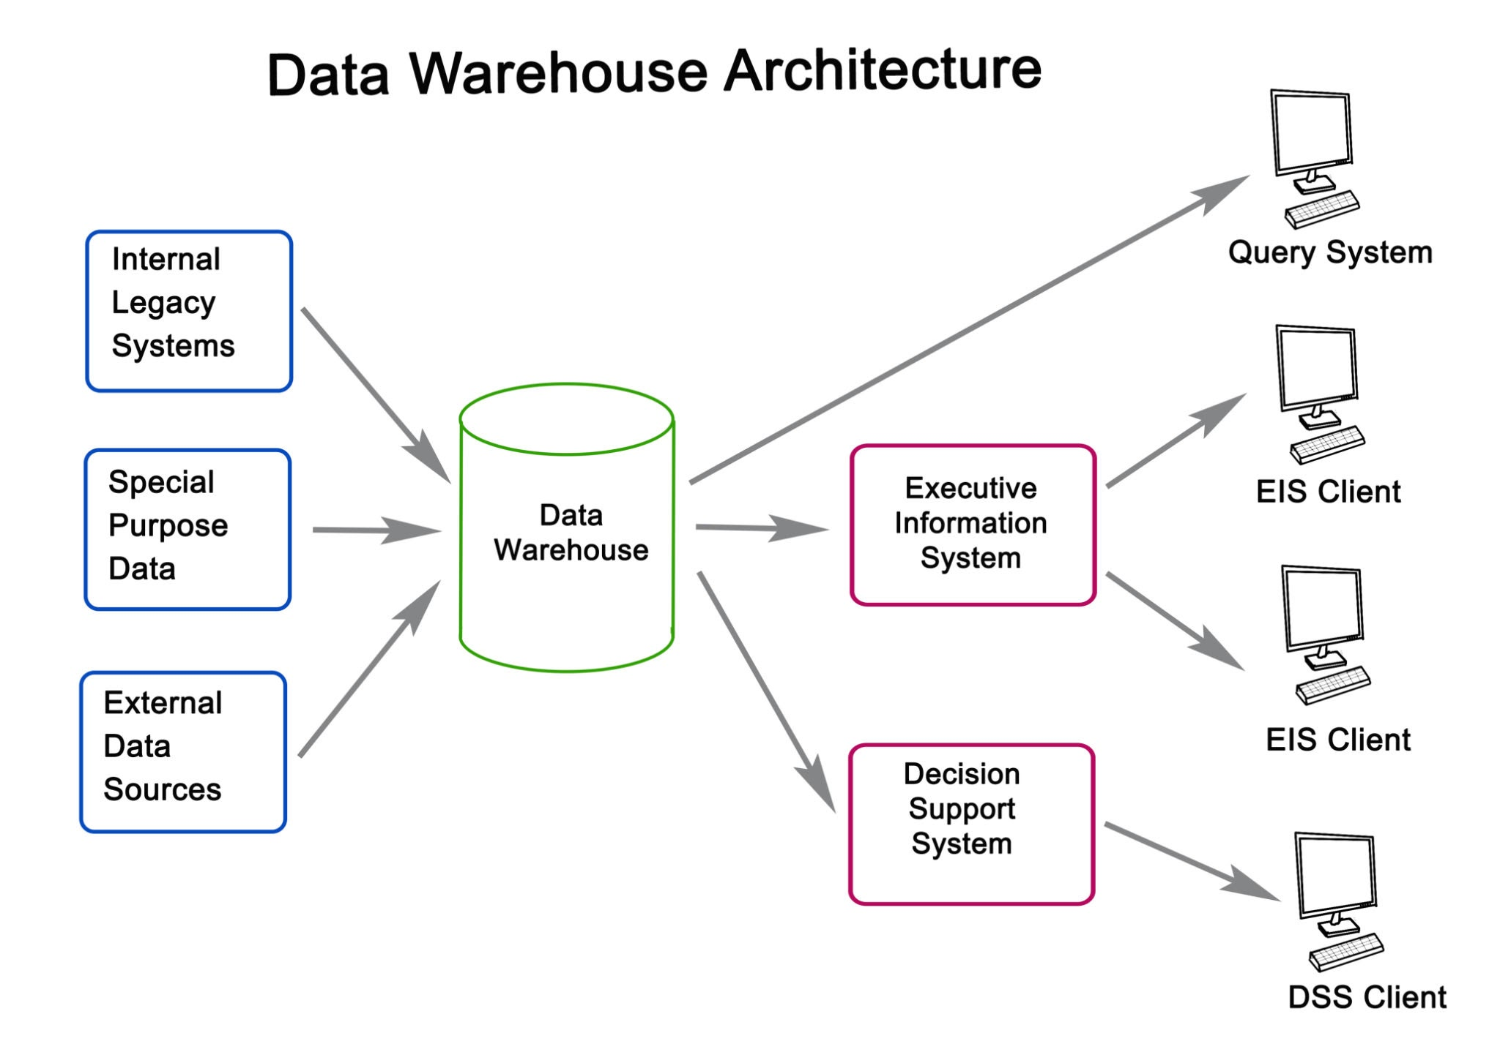
Getty Images
Explore
A picture is worth 1,000 words. It might reveal technical details they forgot to mention (e.g., "Oh, we also check the bank account").
- Elaboration Script: "It helps to visualize if this model runs synchronously (in real-time while the user waits) or asynchronously (in a batch process later). That dictates how fast the model needs to be."
Question 7: Success Metrics
"How do you define 'Success' for this synthetic dataset? Is it the volume of data generated (e.g., 100k rows), or the complexity of the hidden patterns?"
- Why I am asking (Internal Note): I need to know how to get an "A" grade from them.
- Elaboration Script: "I want to ensure I optimize for the right metric. If you need massive scale to stress-test your system, I will focus on performance. If you need subtle, hard-to-detect fraud patterns, I will focus on the complexity of the simulation."

Part 5: Next Steps (The Closing Script)
"Thank you. Based on this, my plan is to:
- Wait for the Schema Template from you.
- Build a small sample dataset (50 rows) focusing on [Insert their chosen Attack Vector].
- Send that sample to you for review by [Insert Date - e.g., next Friday].
Does that sound like a good plan?"

Romano, M. Carmen
0 30:03
Romano, M. Carmen 0 minutes 3 seconds
Thank you, Ziad, for joining us today. I thought it would be useful if you could introduce the overall project. So even though I met Gagan, Tom, Noyang, Mark at the beginning of the week and introduce a little bit, I think it would be really nice and helpful to hear from you.
Romano, M. Carmen 0 minutes 24 seconds
what do you envisage for the project, the milestones, and then maybe we can ask some questions about the objectives. Would that be okay?
ZA

Ziyad Alrasbi
0 350:35
Ziyad Alrasbi 0 minutes 35 seconds
Yeah, absolutely. Yeah, that sounds good.
Ziyad Alrasbi 0 minutes 38 seconds
Yeah, so hi everyone. I'm Ziad and I'm CTO of Zync. And at Zync, we are building a product called Origin, which is essentially a first mile trust infrastructure for digital content ecosystems. And it has an initial focus on the music distribution industry. So the system aims to evaluate its uploads at the moment of submission.
Ziyad Alrasbi 0 minutes 58 seconds
So the moment it is ingested by a platform, and it will assess identity, provenance, behavioural patterns, and any compliance risk before the content is delivered to the digital service providers. So imagine as an artist, you would submit a track onto a distribution platform. The song is not released yet. So there are many layers of fraud that could potentially happen at this stage. So there could be people that upload
Ziyad Alrasbi 1 minute 22 seconds
AI content. They could be uploading songs with other artists who hadn't verified or agreed to being signed onto that song. They could upload copies of other tracks. And there are so many other layers of the fraud system that a lot of distributors are facing nowadays in the music industry. So what we want to do is essentially
Ziyad Alrasbi 1 minute 41 seconds
build what I just mentioned, which is a first mile detection system. So the moment something is uploaded onto a platform, it is detected through the different machine learning algorithms that we will have, and it will be able to cross reference and then create an evidence pack. So at the end of the day, what the distributor gets is an evidence pack that says to them, yeah, this input into your system.
Ziyad Alrasbi 2 minutes 1 second
is allowed, you should allow it in. Maybe it requires review, maybe it requires a quarantine, and maybe it requires a reject. So we have these four different statuses for the different, for the inputs that are coming onto the system. Yeah, that's essentially it for now. Also, it is an API system, so we are operating as...
Ziyad Alrasbi 2 minutes 20 seconds
purely A backend service. There's no portal or anything at this stage. What we aim to do is integrate the API into the workflow of an existing distributor. So we would give them the API URLs, like the different endpoints that they need, an API key, and then they just integrate it into their workflow. And then they have flexibility of how they want to preview the evidence packs. So for example, it could be a HTML file, it could be a JSON, it could be a PDF.
Ziyad Alrasbi 2 minutes 41 seconds
an XML or anything else. So that's pretty much a summary of everything that we have so far. Currently, we're sitting at a prototype has been developed. It is trained on a very, very minimal synthetic data at the moment. So we can verify that the algorithms are functioning as expected, but
ZA
Ziyad Alrasbi
23 minutes 5 seconds23:05
Ziyad Alrasbi 23 minutes 5 seconds
Also, just a couple more things. Amazing. Thank you. Just yeah, two more things. So if we want to keep an open communication as well, I have Discord and I have WhatsApp. So like I don't mind if we can, if we, if you want to set up a group, if we want to set up like a group chat together where we can discuss openly. I don't mind doing that as well.
RC
Romano, M. Carmen
23 minutes 22 seconds23:22
Romano, M. Carmen 23 minutes 22 seconds
Yeah, yeah, that's fine. I just wonder whether instead of WhatsApp, I can do a Teams, a Teams group where then we can include old chats and we can upload files. You would have access, right, Ziad to
ZA
Ziyad Alrasbi
23 minutes 43 seconds23:43
Ziyad Alrasbi 23 minutes 43 seconds
Um...
RC
Romano, M. Carmen
23 minutes 43 seconds23:43
Romano, M. Carmen 23 minutes 43 seconds
To Team, that way.
ZA
Ziyad Alrasbi
23 minutes 45 seconds23:45
Ziyad Alrasbi 23 minutes 45 seconds
I should do so. I have my personal teams. I can send you the e-mail for my personal teams as well, and then we can see if that will work.
RC
Romano, M. Carmen
23 minutes 52 seconds23:52
Romano, M. Carmen 23 minutes 52 seconds
Right. I think as well, in the same way as invited you for this meeting, I should be able to include you. But yes, I will type first maybe with your, the e-mail address that I'm using now.
ZA
Ziyad Alrasbi
24 minutes 5 seconds24:05
Ziyad Alrasbi 24 minutes 5 seconds
Okay.
RC
Romano, M. Carmen
24 minutes 5 seconds24:05
Romano, M. Carmen 24 minutes 5 seconds
And if it doesn't work, then you can send me maybe the other one.
ZA
Ziyad Alrasbi
24 minutes 10 seconds24:10
Ziyad Alrasbi 24 minutes 10 seconds
Okay, yeah, that sounds good. Perfect. Thanks A lot. And then, yeah, secondly, sorry, just one last thing. We are absolutely open to feedback. Any like criticism, anything, we absolutely are open to it. So if there's anything that you think that you guys think should be done differently or can be done differently, we are more than happy to discuss it.
RC
Romano, M. Carmen
24 minutes 13 seconds24:13
Romano, M. Carmen 24 minutes 13 seconds
Okay, great.
ZA
Ziyad Alrasbi
24 minutes 31 seconds24:31
Ziyad Alrasbi 24 minutes 31 seconds
This is an iterative process for us and because the product is not fully launched yet, we want to make sure that it's perfect. So if there are any doubts or anything that you want to bring up or any feedback that you have regarding, for example, the tags or the engines or anything like that, please let me know and we can work on that together as well as we progress.
RC
Romano, M. Carmen
24 minutes 48 seconds24:48
Romano, M. Carmen 24 minutes 48 seconds
I think you know that that that sounds good, and yeah, no, that's that that's really nice to know that we can all openly communicate and yeah, feedback. No, that's great.
Romano, M. Carmen 25 minutes 1 second
OK, yes, the last thing Ziad is I will finalise the non-disclosure agreement. So for GAGAN, TONMOY and MARK, I didn't mention that, but because we are working with SINGH, we need all to sign a non-disclosure agreement.
ZA
Ziyad Alrasbi
25 minutes 13 seconds25:13
Ziyad Alrasbi 25 minutes 13 seconds
Sure.
RC
Romano, M. Carmen
25 minutes 22 seconds25:22
Romano, M. Carmen 25 minutes 22 seconds
So our legal advisor from the university will be in touch with you and will ask you to sign a PDF document.
Romano, M. Carmen 25 minutes 32 seconds
Just that that you're prepared and not surprised when when you see the e-mail.
SG
SAINI, GAGAN (PGT)
25 minutes 37 seconds25:37
SAINI, GAGAN (PGT) 25 minutes 37 seconds
Yeah, sure.
RC
Romano, M. Carmen
25 minutes 39 seconds25:39
Romano, M. Carmen 25 minutes 39 seconds
Okay, so her name is Jackie Bizo. So if you see an e-mail from her, it will be regarding the non-disclosure agreement.
Romano, M. Carmen 25 minutes 49 seconds
Okay, perfect. Yes, thank you very much, Siad.
ZA
Ziyad Alrasbi
25 minutes 53 seconds25:53
Ziyad Alrasbi 25 minutes 53 seconds
No worries and thanks a lot guys for your time and thank you for the questions.
RC
Romano, M. Carmen
25 minutes 56 seconds25:56
Romano, M. Carmen 25 minutes 56 seconds
Yeah, thank you. See you next week. Bye bye.
ZA
Ziyad Alrasbi
25 minutes 56 seconds25:56
Ziyad Alrasbi 25 minutes 56 seconds
I look forward to this.
Ziyad Alrasbi 25 minutes 59 seconds
Bye, bye. Thanks, guys. Bye.
RC
Romano, M. Carmen
26 minutes 1 second26:01
Romano, M. Carmen 26 minutes 1 second
Bye.

account_external_id, account_type, display_name, upload_external_id, metadata_title, metadata_genre, metadata_duration_seconds, metadata_bitrate, metadata_format, metadata_collaborators, metadata_album, metadata_year, content_ref, fingerprints_audio_hash, fingerprints_perceptual_hash, device_context_device_hash, device_context_ip, device_context_user_agent, expected_category, profile_type

